Krishna Gupta
CSE-C
202401100200176
Web Technology Assignment-01

1. Create a function using the rest operator to accept multiple numbers and return their sum.

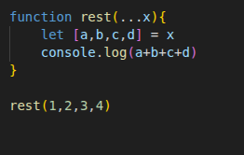
Code:

Output:

2.Merge two arrays using the spread operator.

Code:
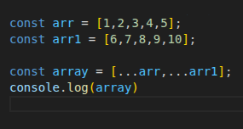

Output:
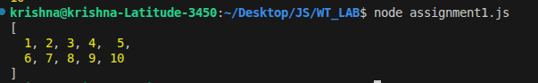

3. Copy and update an object using the spread operator.

Code:

